**PHOTOGRAPHY ASSIGNMENT**

***(Exposure Practice using Camera Sim, Application)***

Samuel Manas

2024001297

**Introduction:**

This assignment is designed to develop a practical understanding of photographic exposure through hands-on experimentation using the Camera Sim application. The study focuses on examining the interaction between ISO, aperture, and shutter speed while operating strictly in Manual Mode. By producing underexposed, overexposed, and correctly exposed images, the simulations demonstrate how exposure settings influence brightness, depth of field, motion control, and image sharpness. This practical approach helps translate theoretical concepts of exposure into informed photographic decision-making.

All the simulations were performed using Camera Sim in Manual Mode.

# **ISO Adjustments: (Photos 1–3)**

***Photo 1:***

Correctly Exposed:

**Before:**

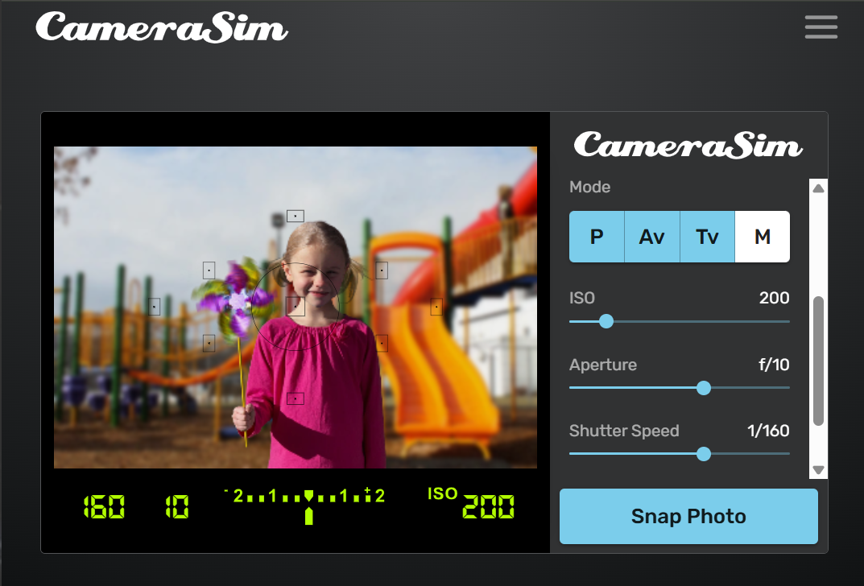

**After:**

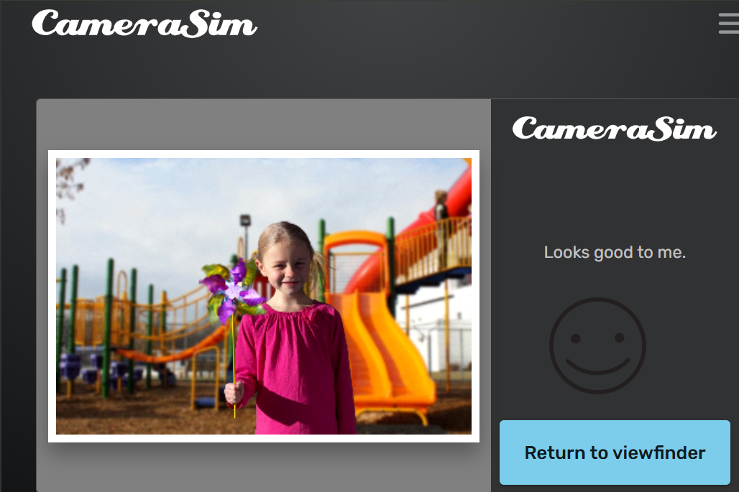

**Settings Used:**

* ISO: 200
* Aperture: f/10
* Shutter Speed: 1/160

**How the Exposure Changed:**  
The exposure meter was centered, indicating correct exposure. The image had balanced brightness.

**Effects on Image:**

* **Depth of Field:** Moderate depth of field; background slightly visible
* **Motion Blur:** None, subject appears sharp
* **Image Clarity:** Clear image with minimal noise

**Challenges Faced:**  
Finding the ISO value that balanced brightness without overexposing highlights.

**What I Learned:**  
ISO controls brightness without affecting motion or depth of field, but higher ISO can introduce noise.

***Photo 2:***

Underexposed:

**Before:**

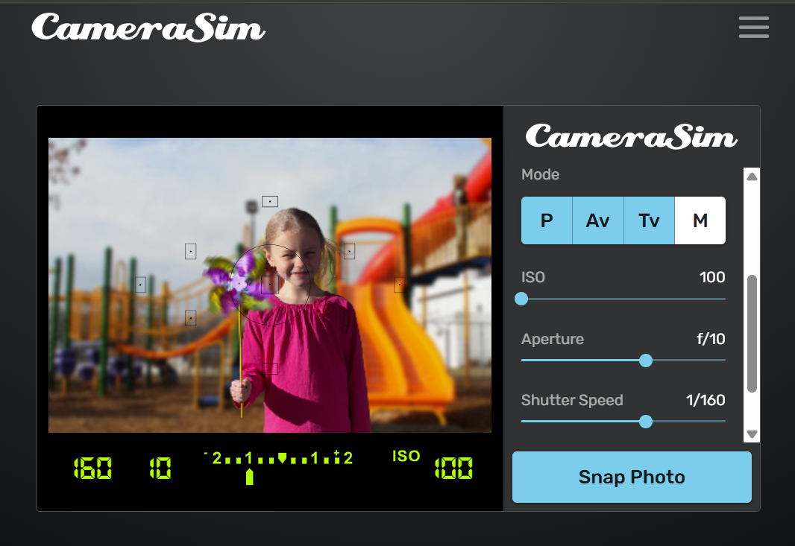

**After:**

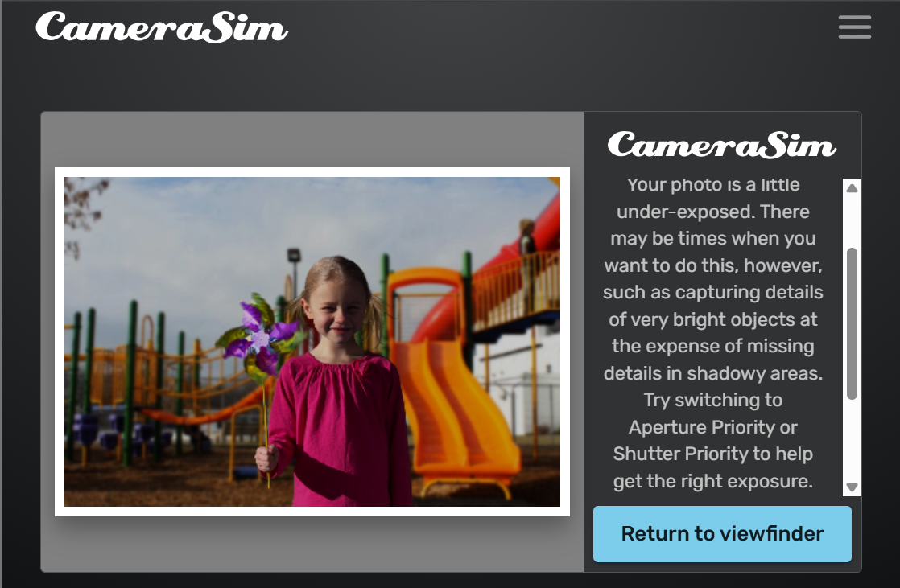

**Settings Used:**

* ISO: 100
* Aperture: f/10
* Shutter Speed: 1/160

**How the Exposure Changed:**Lowering ISO reduced the sensor’s light sensitivity, causing underexposure.

**Effects on Image:**

* Depth of Field: Same as correct exposure
* Motion Blur: None
* Image Clarity: Darker image with loss of shadow details

**Challenges Faced:**Maintaining detail in darker areas when ISO is too low.

**What I Learned:**Low ISO produces cleaner images but requires sufficient light to avoid underexposure.

***Photo 3:***

Overexposed:

**Before:**

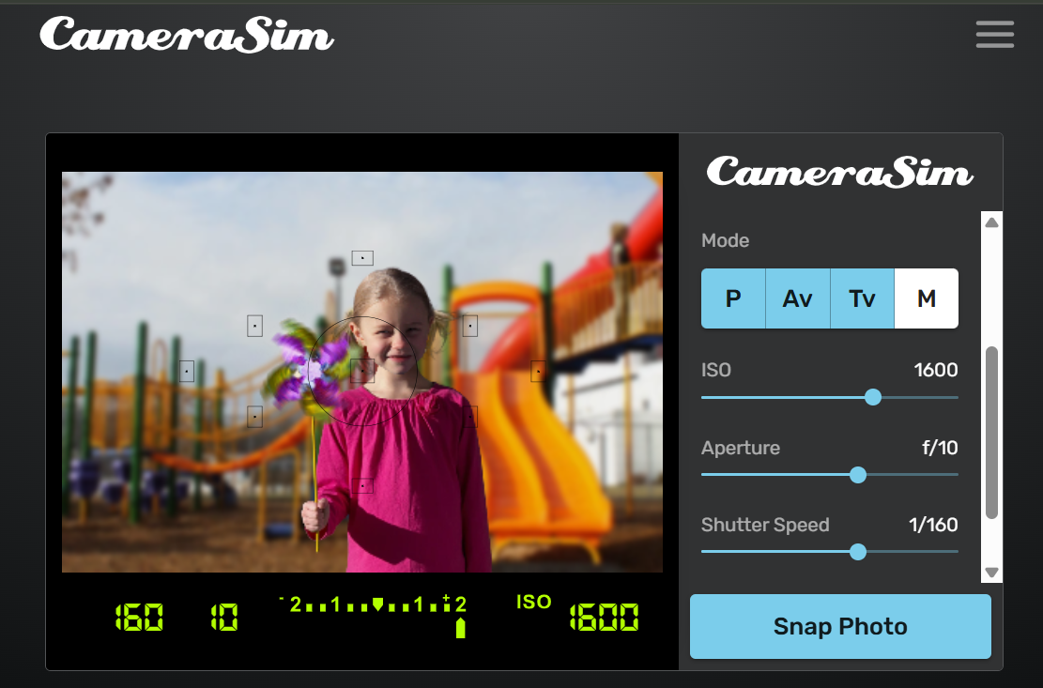

**After:**

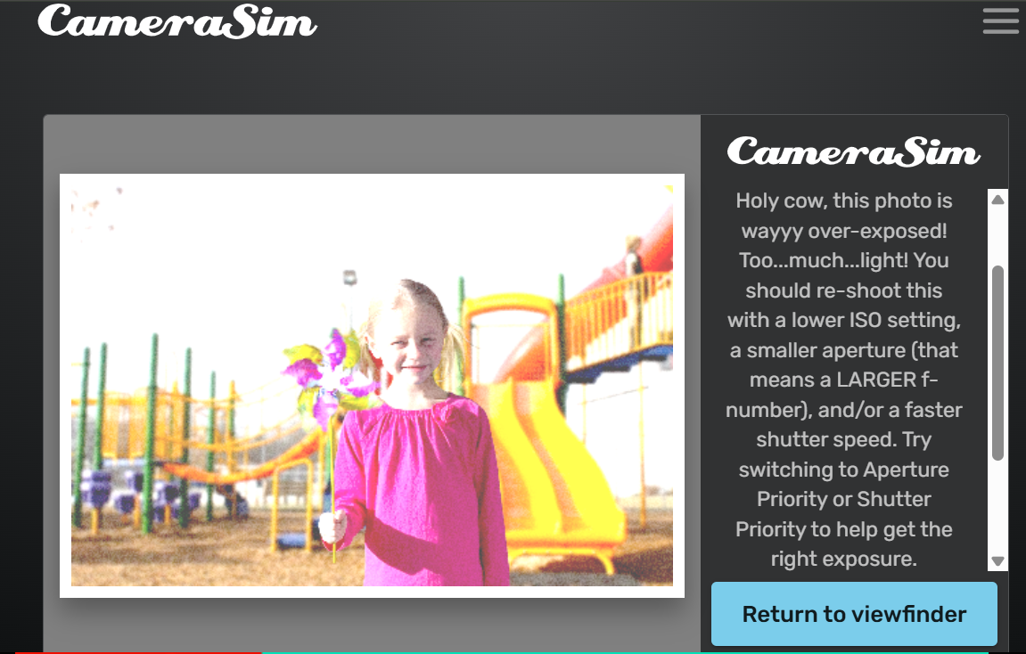

**Settings Used:**

* ISO: 1600
* Aperture: f/10
* Shutter Speed: 1/160

**How the Exposure Changed:**  
Increasing ISO made the image excessively bright.

**Effects on Image:**

* Depth of Field: No change
* Motion Blur: None
* Image Clarity: Highlights blown out; visible noise

**Challenges Faced:**Controlling excessive brightness caused by high ISO.

**What I Learned:**Very high ISO should be avoided in bright conditions as it causes noise and overexposure.

# **Aperture Adjustments: (Photos 4–6)**

***Photo 4:***

Correctly Exposed:

**Before:**

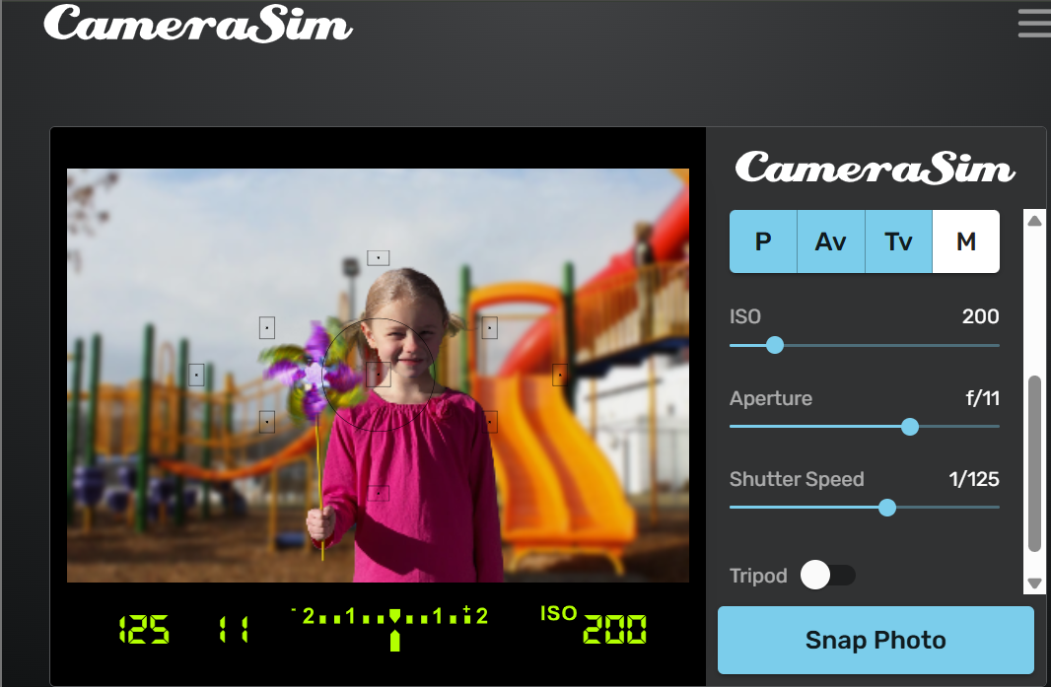

**After:**

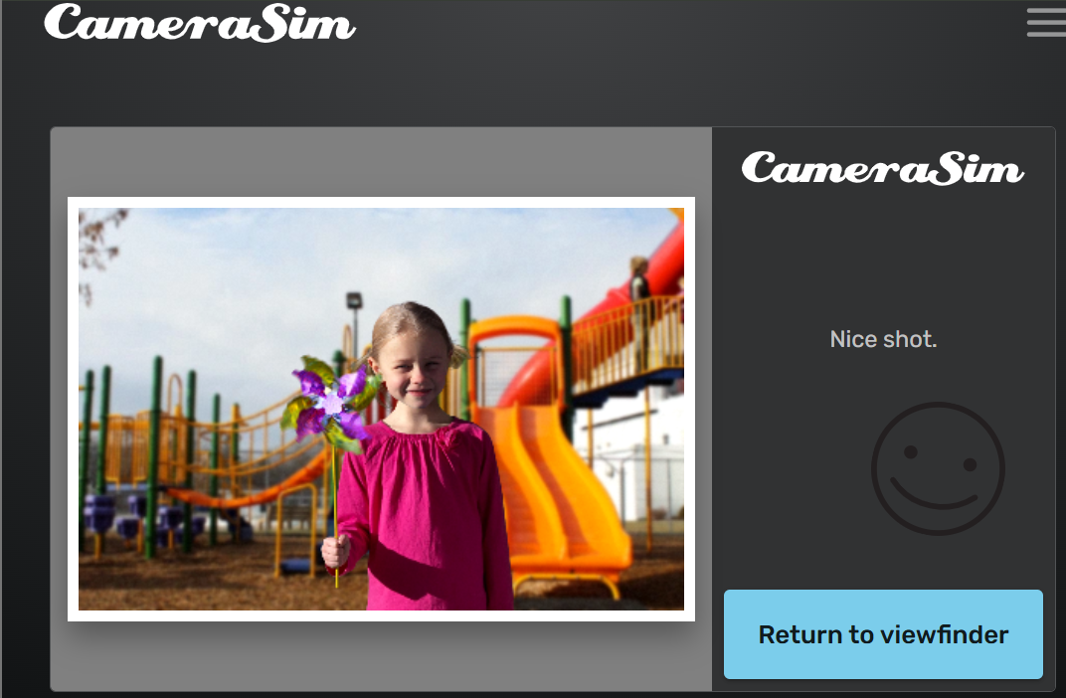

**Settings Used:**

* ISO: 200
* Aperture: f/11
* Shutter Speed: 1/125

**How the Exposure Changed:**Balanced aperture allowed enough light for correct exposure.

**Effects on Image:**

* Depth of Field: Deep depth of field; background clearer
* Motion Blur: None
* Image Clarity: Sharp and well-exposed

**Challenges Faced:**  
Balancing light intake while maintaining depth of field.

**What I Learned:**Aperture affects both brightness and depth of field.

***Photo 5:***

Underexposed:

**Before:**

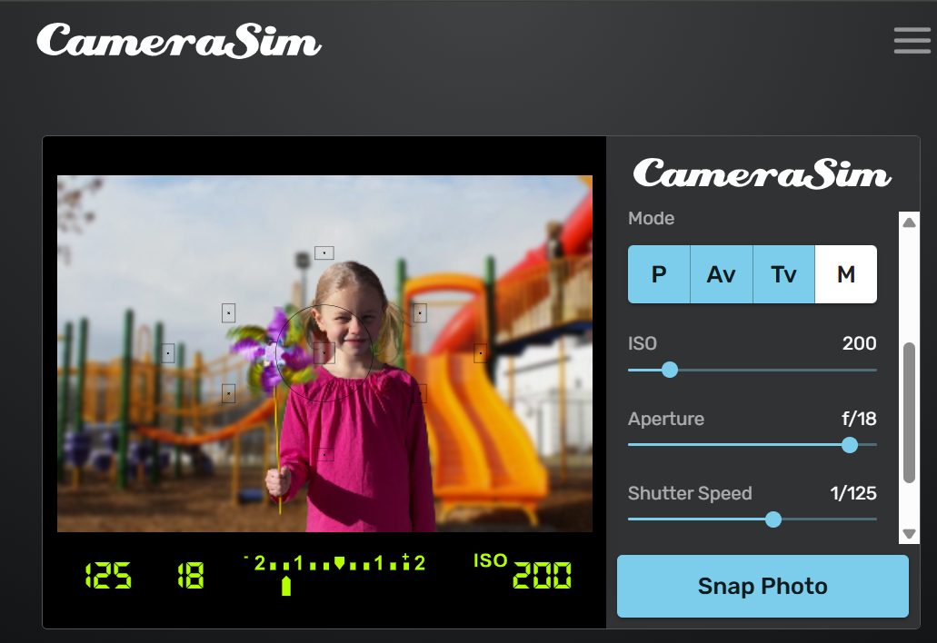

**After:**

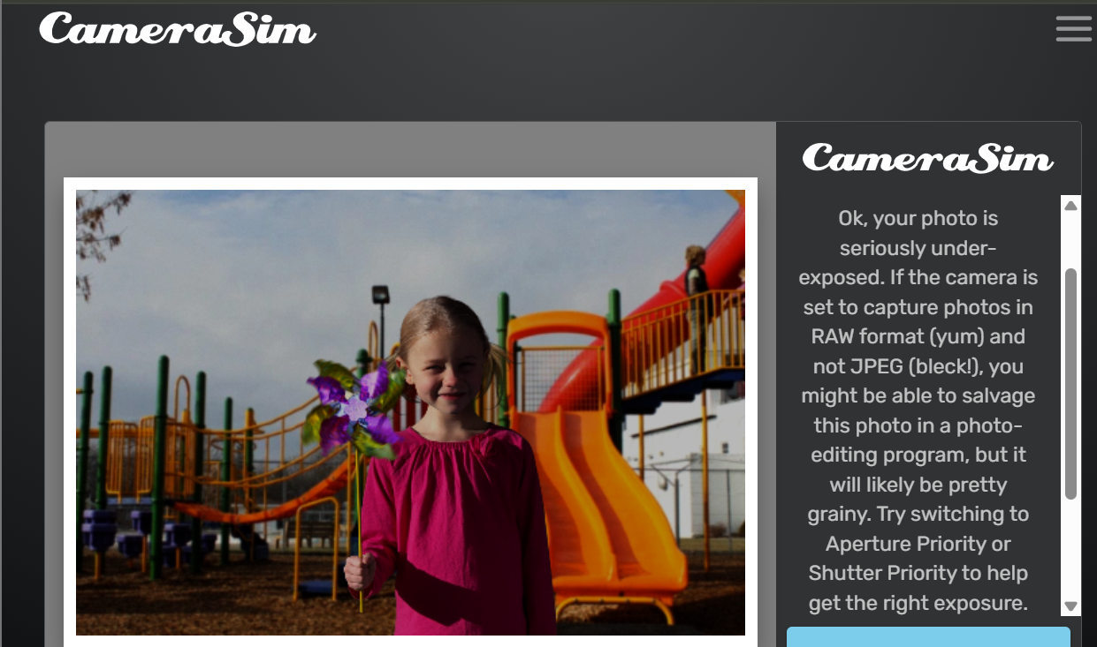

**Settings Used:**

* ISO: 200
* Aperture: f/18
* Shutter Speed: 1/125

**How the Exposure Changed:**Smaller aperture restricted light, causing underexposure.

**Effects on Image:**

* Depth of Field: Very deep
* Motion Blur: None
* Image Clarity: Dark image with reduced brightness

**Challenges Faced:**Avoiding underexposure while using small apertures.

**What I Learned:**Smaller apertures require compensation through ISO or shutter speed.

***Photo 6:***

Overexposed:

**Before:**

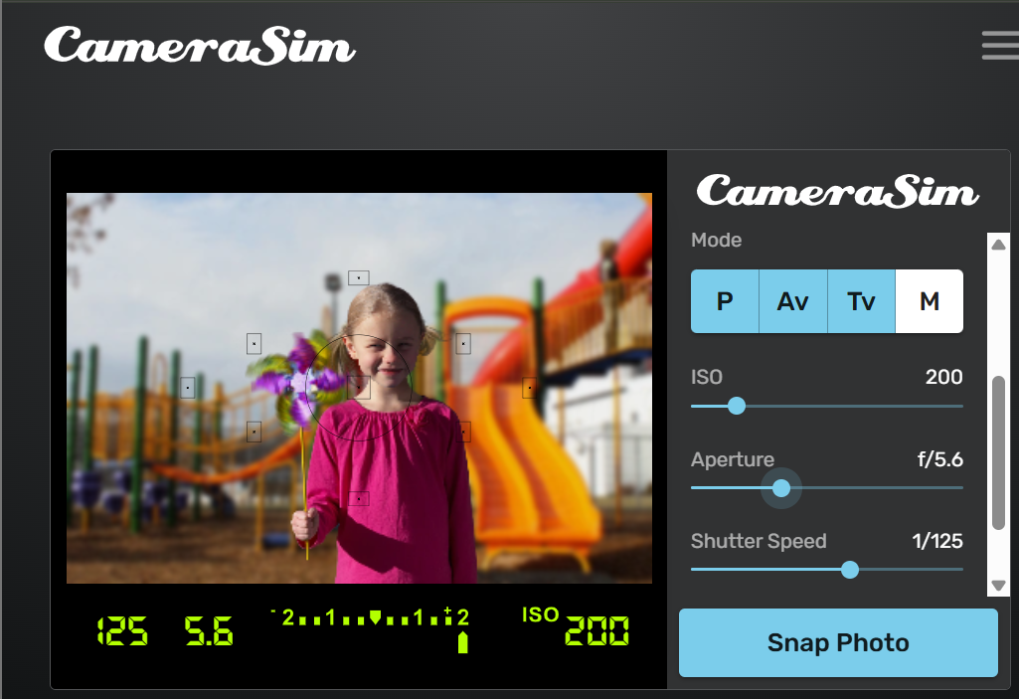

**After:**

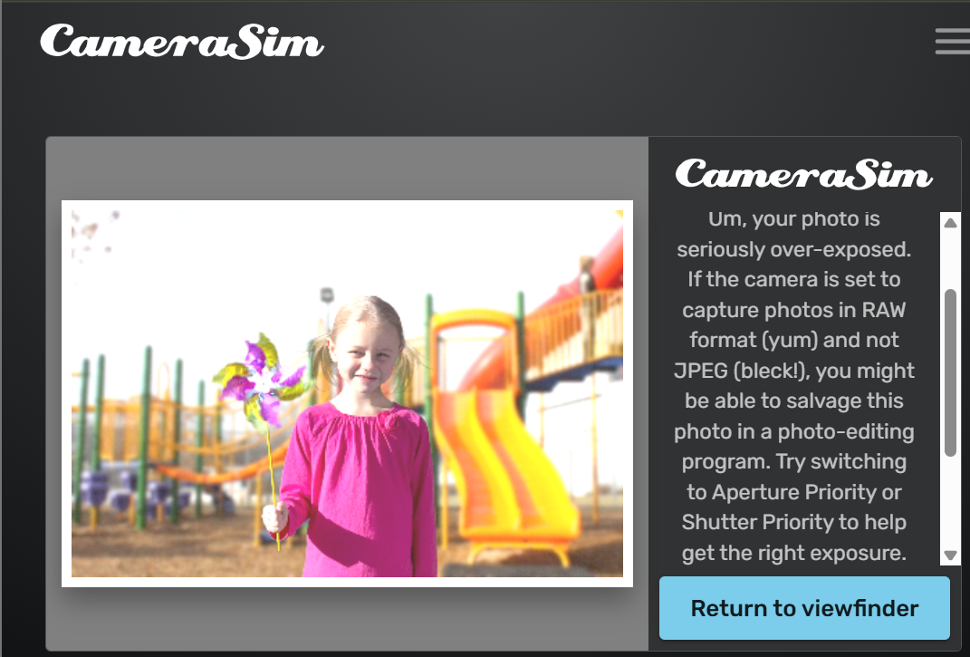

**Settings Used:**

* ISO: 200
* Aperture: f/5.6
* Shutter Speed: 1/125

**How the Exposure Changed:**Wider aperture allowed too much light, resulting in overexposure.

**Effects on Image:**

* Depth of Field: Shallow background blur
* Motion Blur: None
* Image Clarity: Bright image with highlight loss

**Challenges Faced:**Preventing overexposure while achieving background blur.

**What I Learned:**Wide apertures are useful for subject isolation but must be controlled.

# **Shutter Speed Adjustments: (Photos 7–9)**

***Photo 7:***

Correctly Exposed:

**Before:**

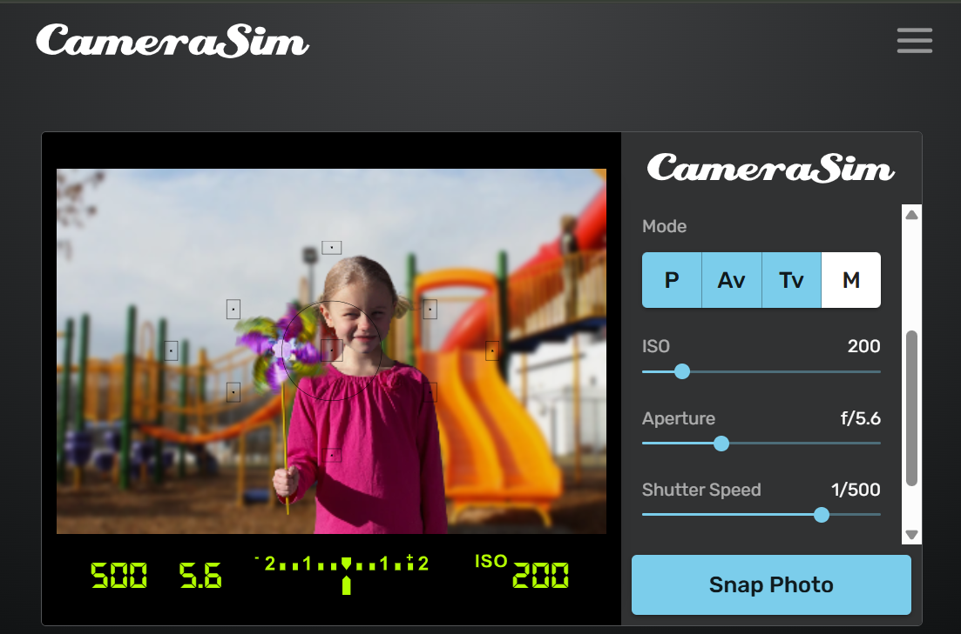

**After:**

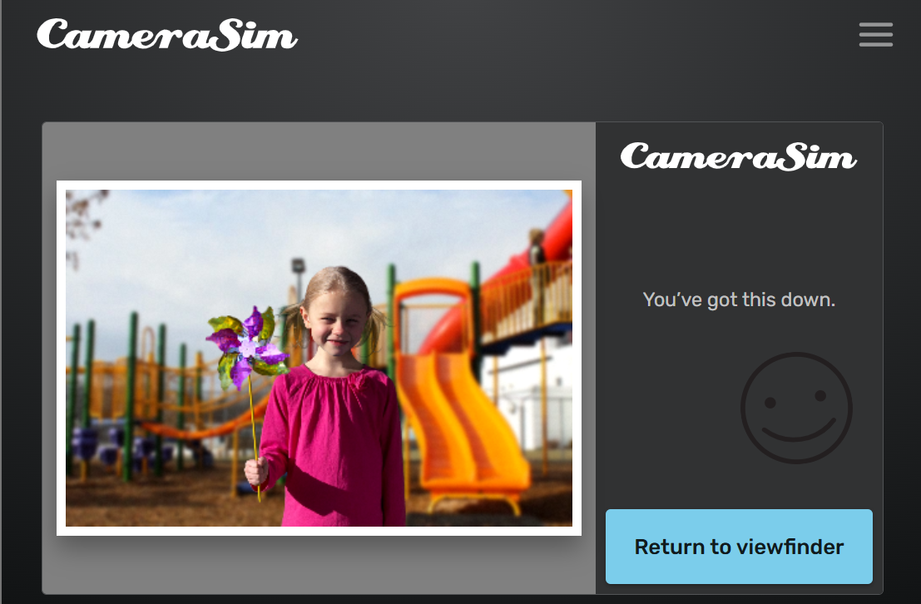

**Settings Used:**

* ISO: 200
* Aperture: f/5.6
* Shutter Speed: 1/500

**How the Exposure Changed:**Fast shutter speed maintained correct exposure.

**Effects on Image:**

* Depth of Field: Moderate
* Motion Blur: Frozen motion
* Image Clarity: Very sharp

**Challenges Faced:**Maintaining brightness with faster shutter speed.

**What I Learned:**Fast shutter speeds are ideal for freezing motion.

***Photo 8:***

Underexposed:

**Before:**

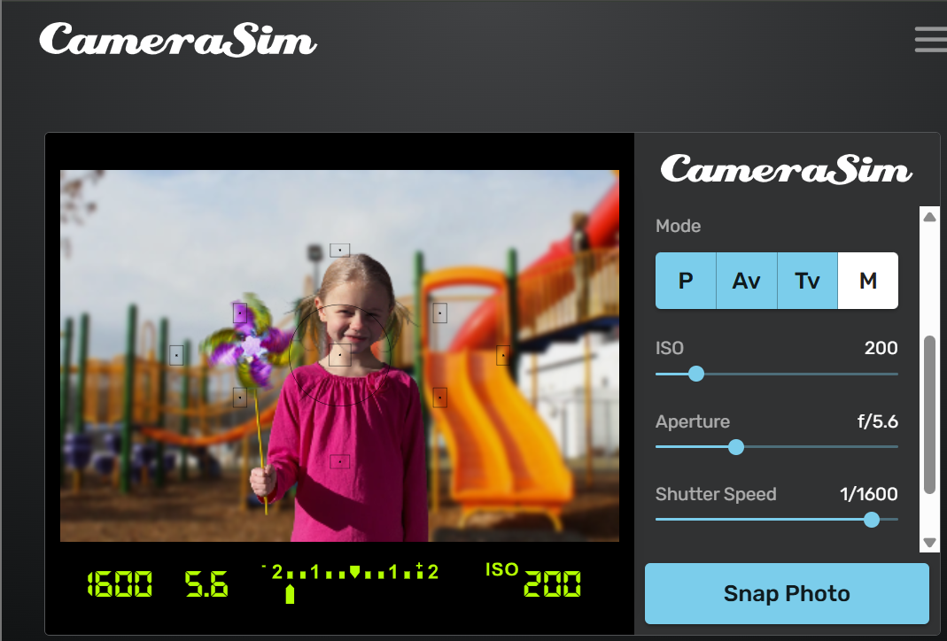

**After:**

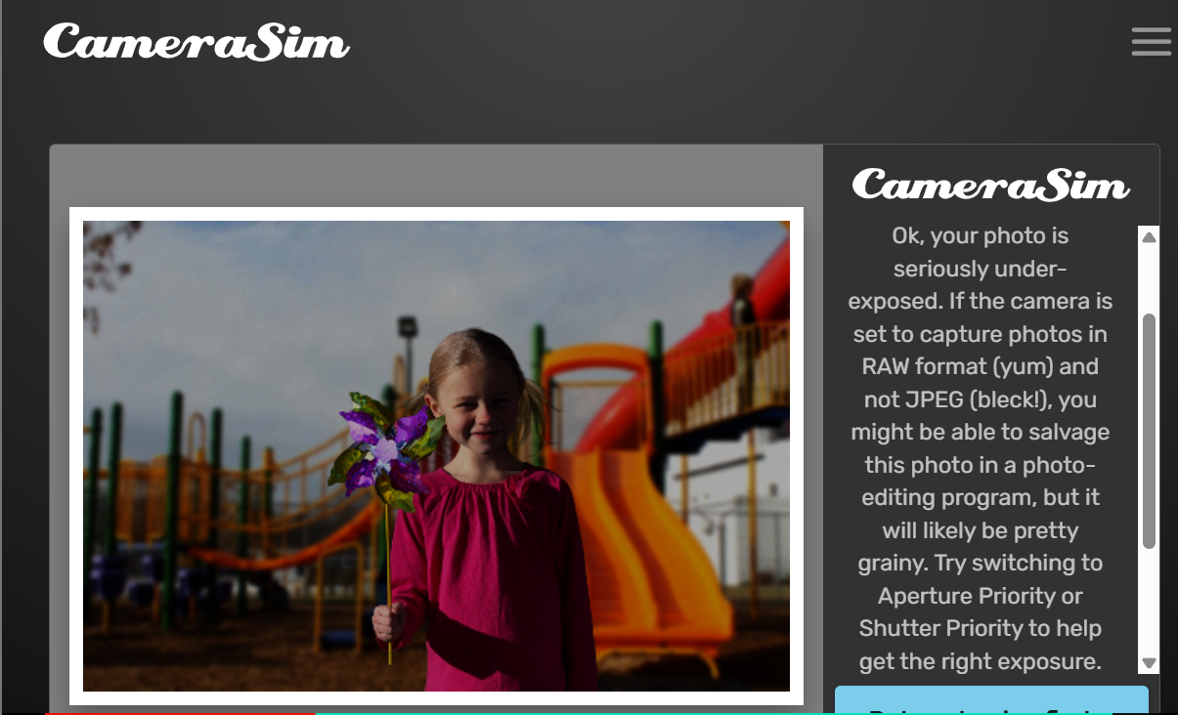

**Settings Used:**

* ISO: 200
* Aperture: f/5.6
* Shutter Speed: 1/1600

**How the Exposure Changed:**Very fast shutter reduced light entry.

**Effects on Image:**

* Depth of Field: Same
* Motion Blur: None
* Image Clarity: Dark image

**Challenges Faced:**Balancing exposure with very fast shutter speeds.

**What I Learned:**Excessively fast shutter speeds require compensation.

***Photo 9:***

Overexposed:

**Before:**

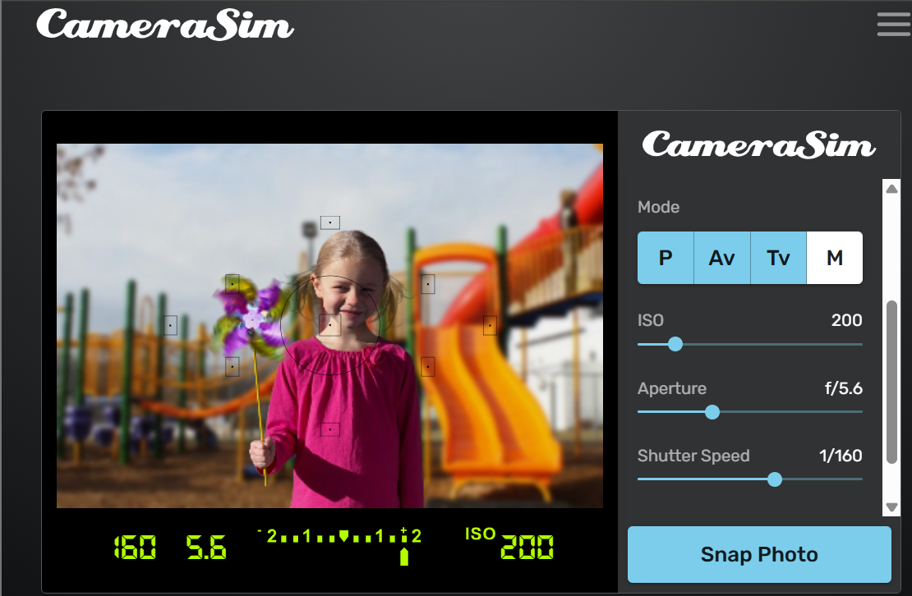

**After:**

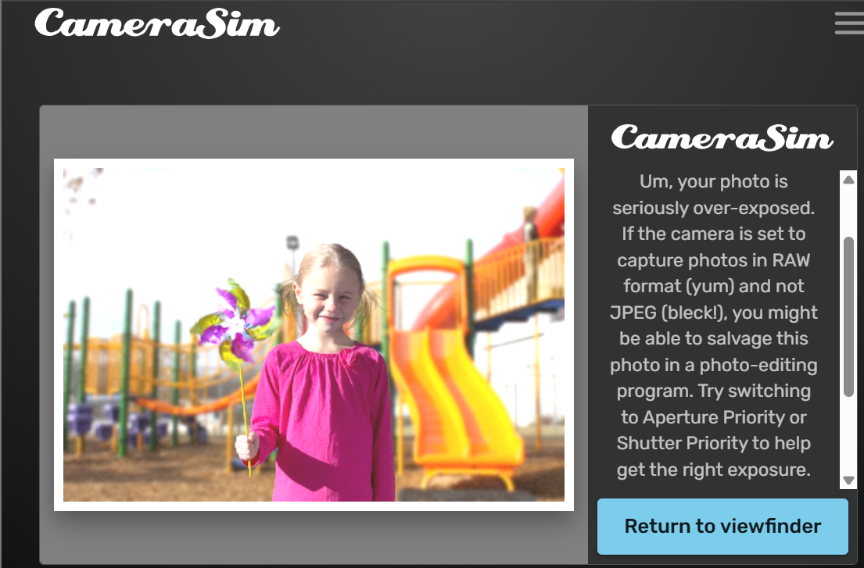

**Settings Used:**

* ISO: 200
* Aperture: f/5.6
* Shutter Speed: 1/160

**How the Exposure Changed:**Slower shutter allowed excess light.

**Effects on Image:**

* Depth of Field: Same
* Motion Blur: Slight risk
* Image Clarity: Overly bright image

**Challenges Faced:**Avoiding motion blur while slowing shutter speed.

**What I Learned:**Shutter speed directly affects motion and brightness.

# **Final Balanced Exposure: (Photo 10)**

***Photo 10:***

**Before:**

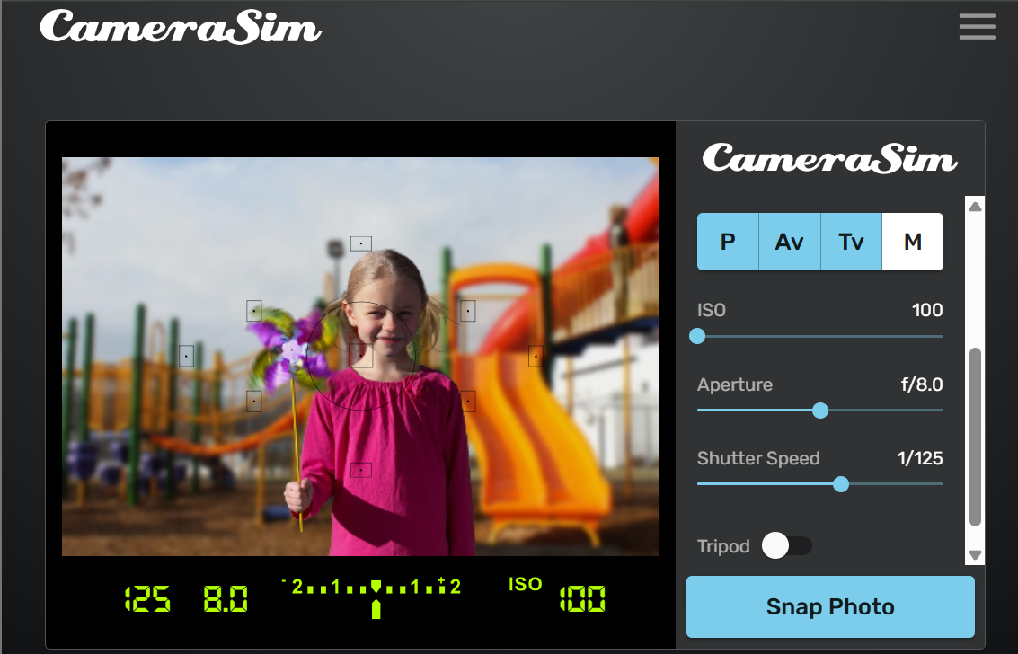

**After:**

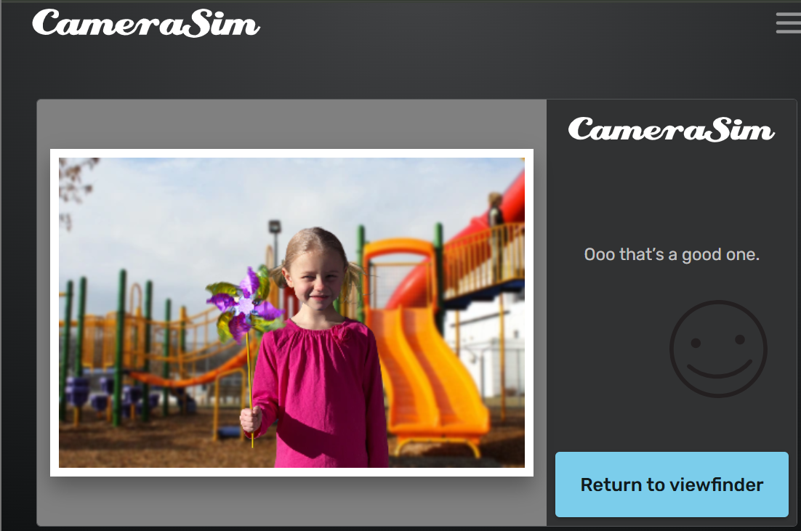

**Settings Used:**

* ISO: 100
* Aperture: f/8
* Shutter Speed: 1/125

**How the Exposure Changed:**All three settings were balanced to achieve correct exposure.

**Effects on Image:**

* Depth of Field: Balanced
* Motion Blur: None
* Image Clarity: Clean, sharp, well-exposed image

**Challenges Faced:**Balancing all three exposure elements simultaneously.

**What I Learned:**Proper exposure is achieved through the combined control of ISO, aperture, and shutter speed.

**Conclusion:**

In conclusion, this exposure practice provided valuable insight into the combined role of ISO, aperture, and shutter speed in achieving correct photographic exposure. The simulations clearly illustrated how adjusting each parameter affects image brightness, depth of field, motion blur, and overall clarity. The final balanced exposure emphasized the importance of coordinating all three exposure elements rather than relying on a single adjustment. Overall, the exercise strengthened practical skills in Manual Mode and enhanced confidence in controlling exposure effectively.